Writing Assignment  
Developer Documentation Specialist

When completed, submit to your recruiter along with any writing samples of previous work.

|  |
| --- |
| **Provide examples/references of “well-documented” APIs or developer documentation, describing what makes them stand out.** |
|  |

# 

|  |
| --- |
| **How would you improve the following explanations?** Rewrite the following examples below, reflecting your improvements.  ***Example 1*** *“NodeJS ecosystem is very big and it is still growing day by day. It is an asynchronous event driven environment that uses google's v8 engine to run javascript. V8 is the same engine used in google chrome to run JavaScript.*  *As it is asynchronous in nature, you should be able to leverage or handle it efficiently. So I highly recommend that once you finish this guide, you read about callback hell and promises.*  *This article will focus on covering the tools that will help you as a beginner to better understand the environment. Hovever, if you're already a NodeJS developer then you might already know these.*  *The official docs explains NodeJS very efficiently in a concise manner. If you're interested then give it 5 minutes of your time.”*  ***Example 2*** *“The Data Type of a variable plays an important role in statistics which must be understood, to correctly apply statistical measurements to your data. In statistics, the term "Measurement Scale" may be used as well.”* |
| **Example 1** |
| **Example 2** |

# 

|  |
| --- |
| **Tutorial** |
| Follow and complete the instructions outlined in this Webhooks tutorial. As part of the final step, print the webhook result to an HTML page. Provide a copy of the app code via GitHub.  To obtain the proper credentials for the tutorial, sign up for a free 15-day trial here:  <https://www.bigcommerce.com/essentials/>  Webhook Tutorial: <https://developer.bigcommerce.com/api-docs/getting-started/webhooks/setting-up-webhooks>  Optional: See opportunities to improve this tutorial? Let us know.  Tutorial URL:  <https://developer.bigcommerce.com/api-docs/store-management/webhooks/tutorial#getting-started> |

# 

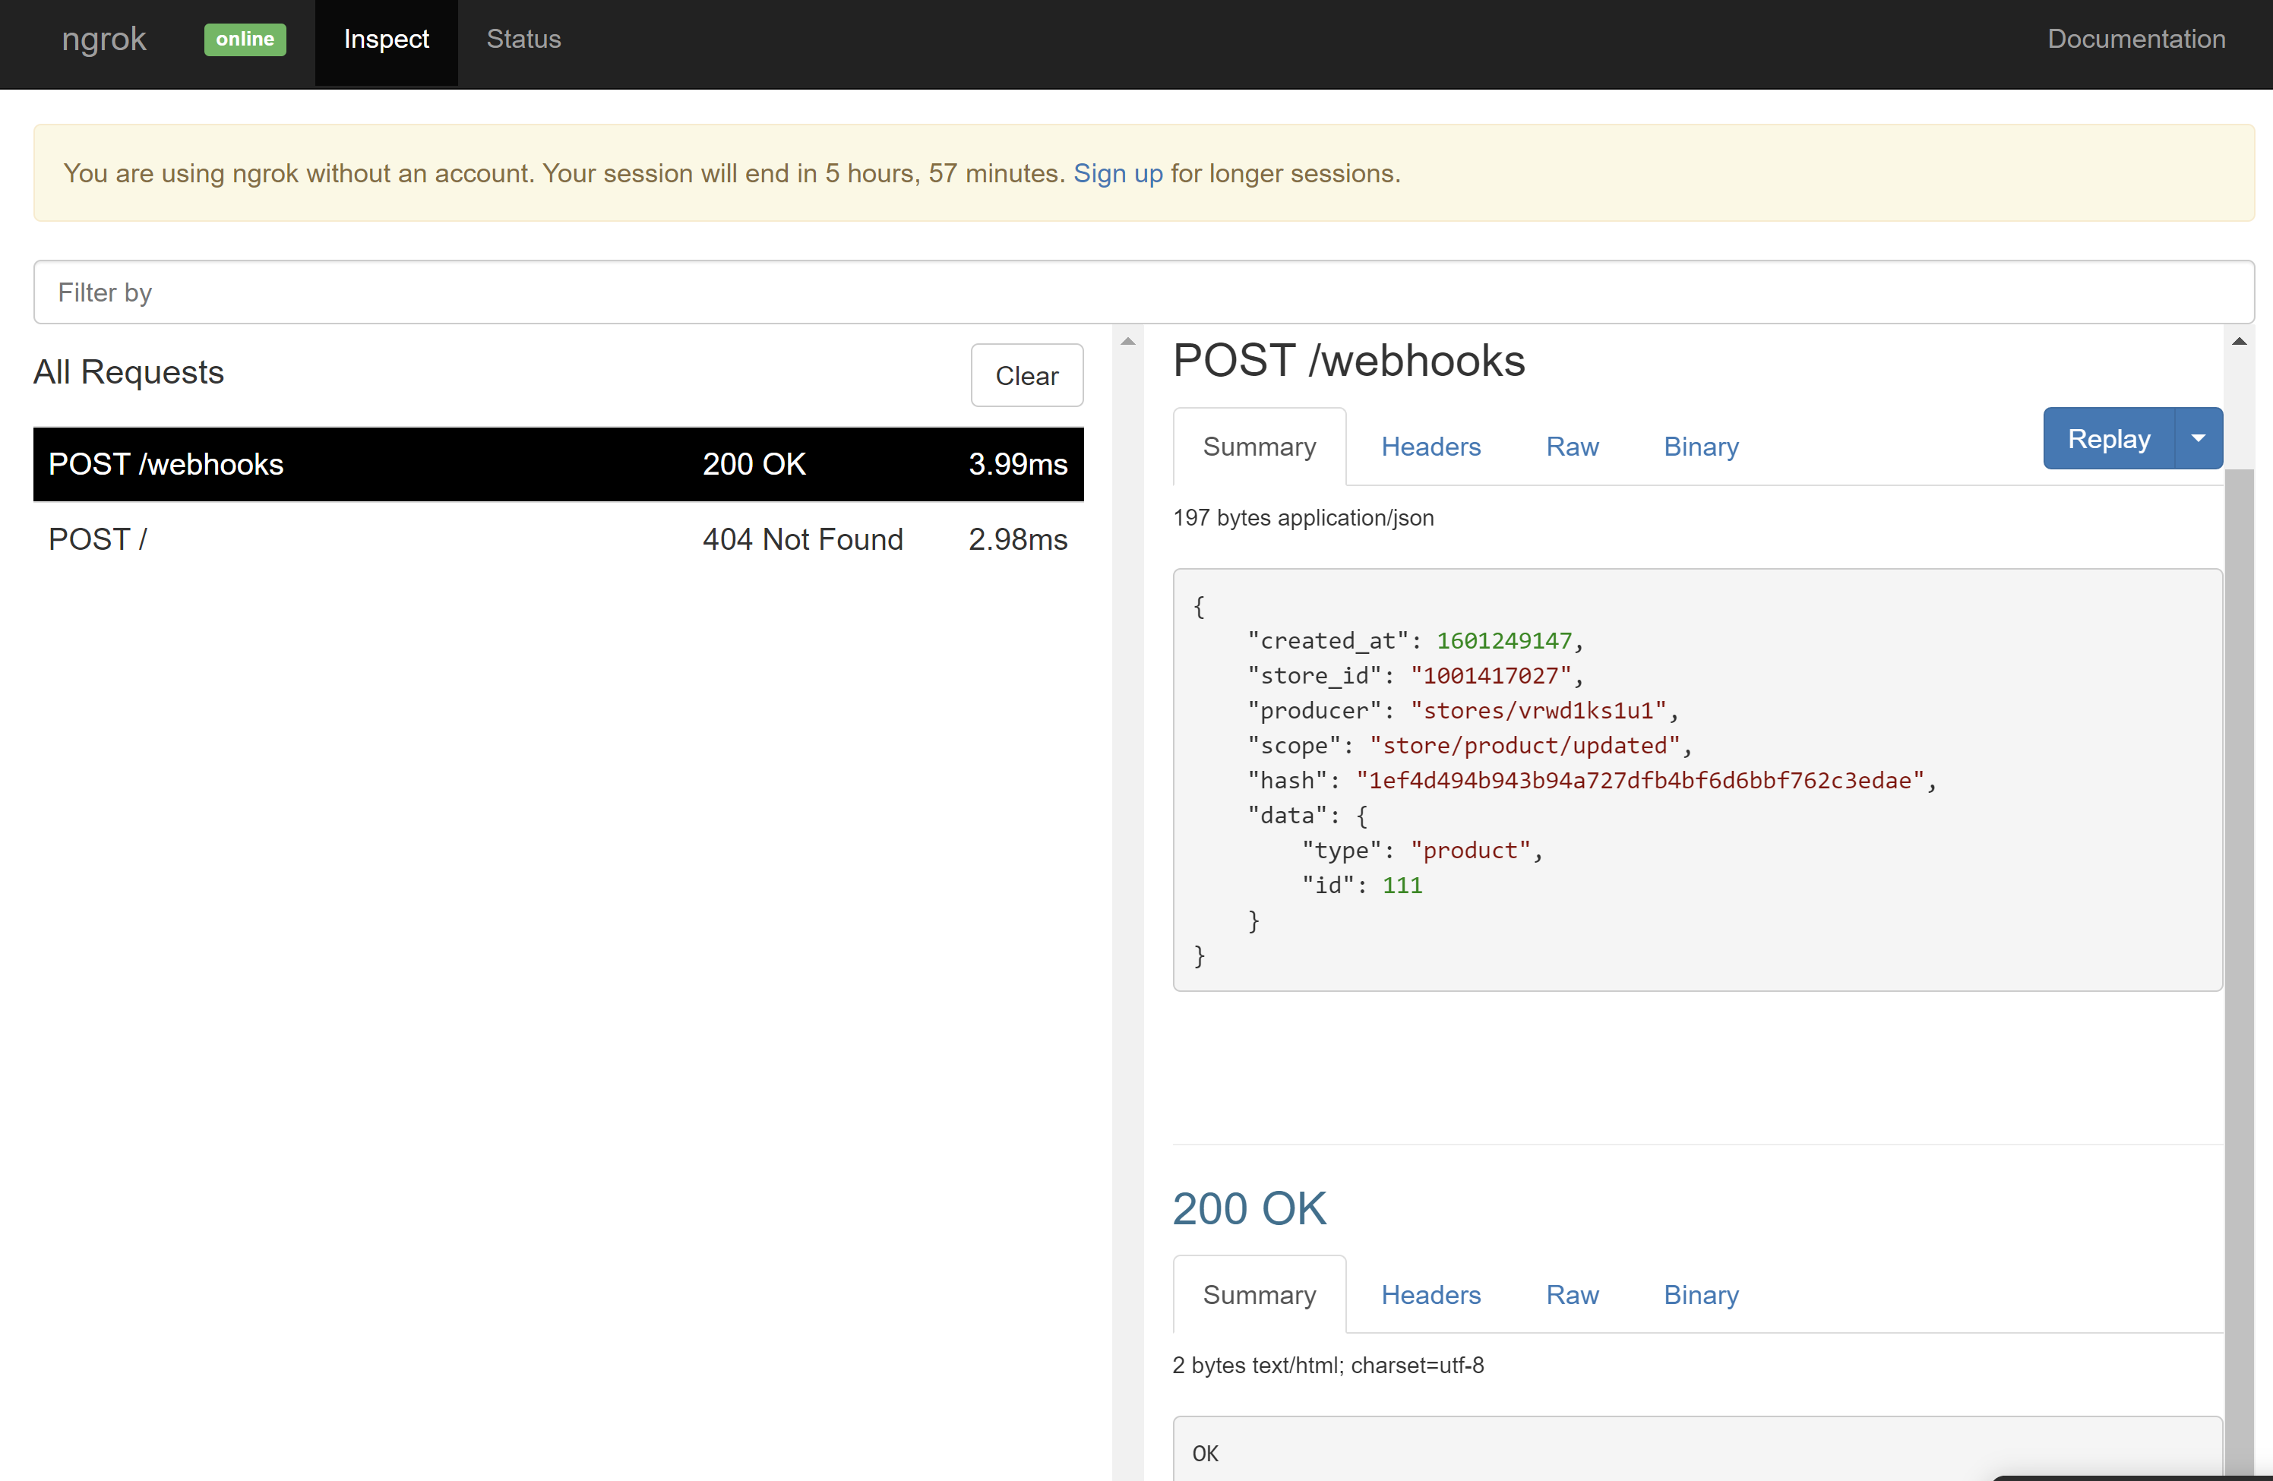

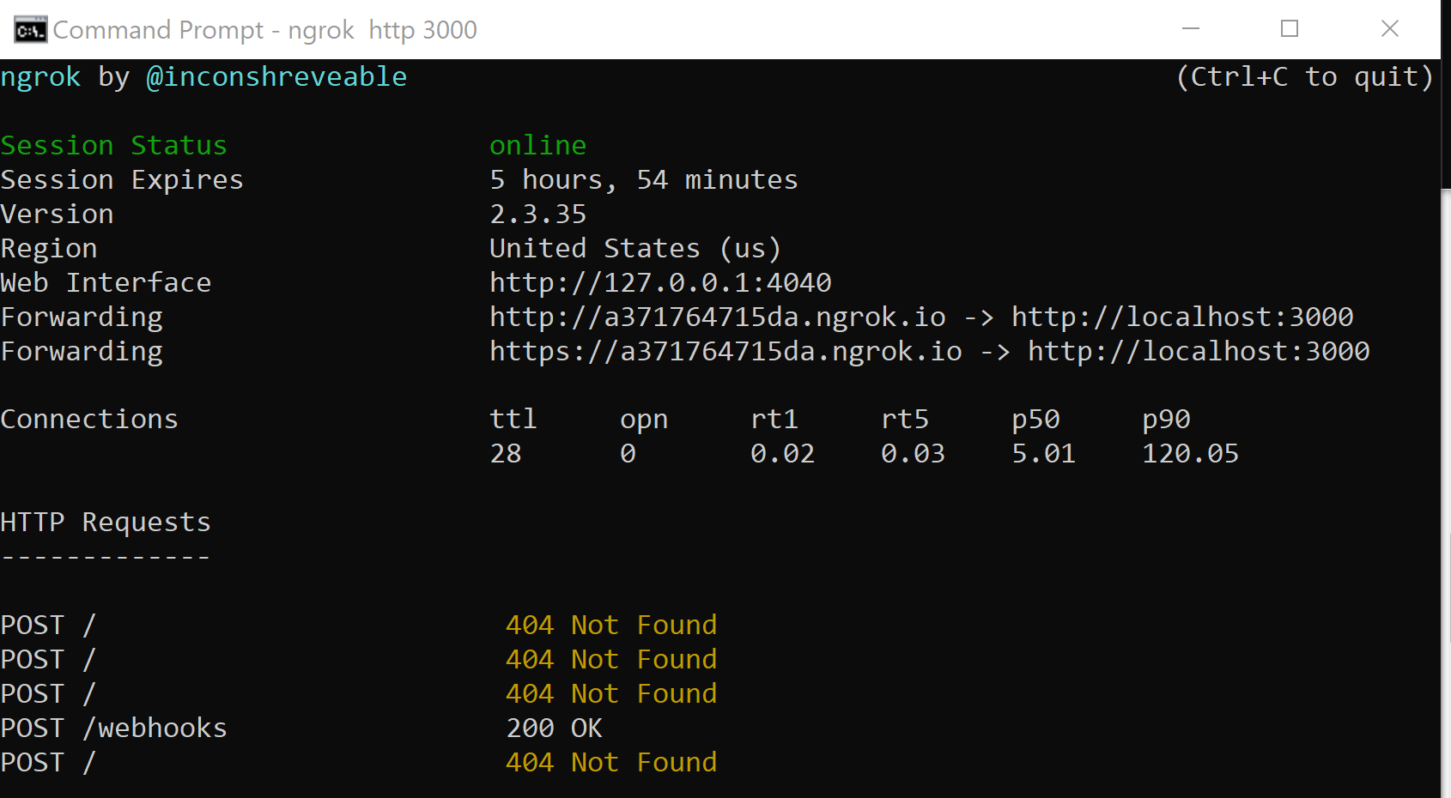

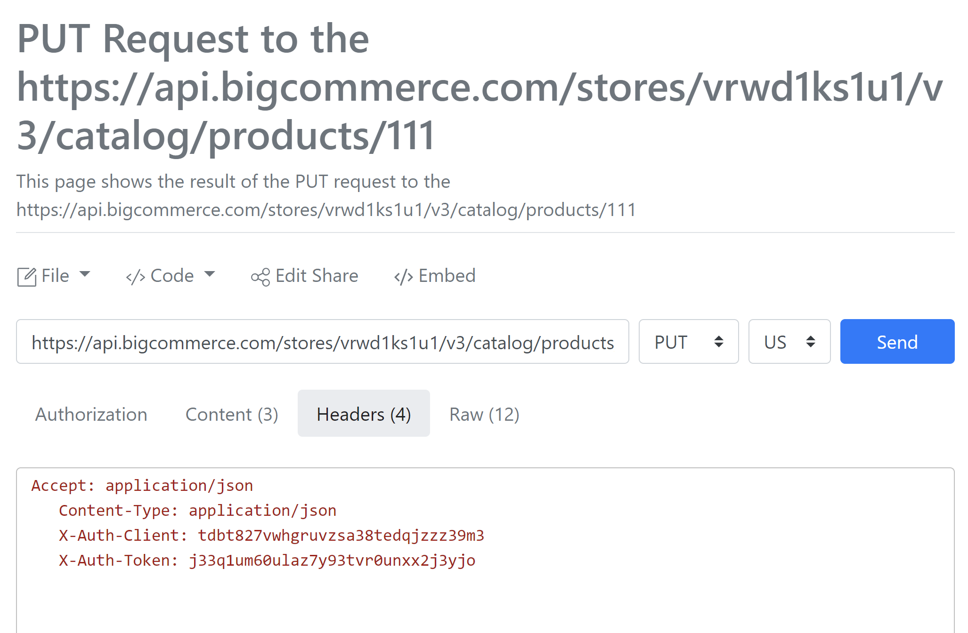

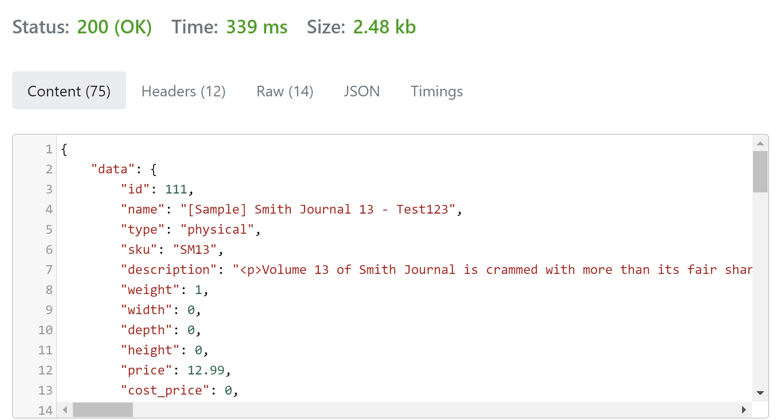

|  |
| --- |
| **What recommendations would you make for improving our current documentation overall?** |
|  |
|  |

# 

|  |
| --- |
| **Writing Samples** |
| Please include **three** relevant documentation samples of previous work.  Answer the questions below for each sample you provide.     1. Does the document represent original writing or does it represent existing content that you revised? 2. How much of the content did you write? If you only wrote portions of the document, which portions? 3. Where did you get the information to write the document? 4. If applicable, explain how you obtained any code samples. 5. Provide any useful context for the sample, such as deadlines, achievements, etc. |